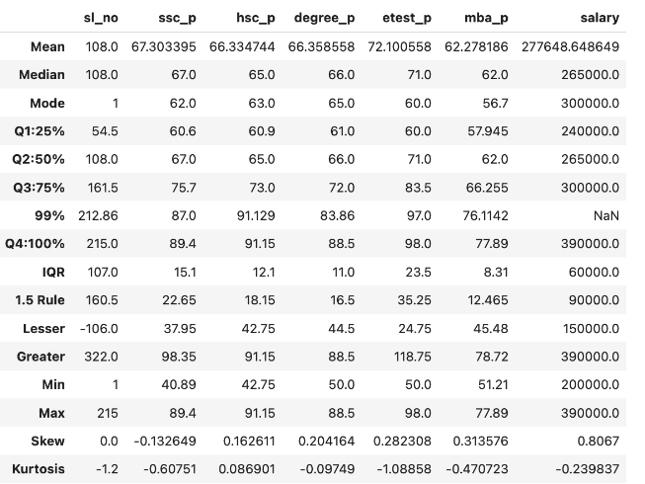

**Analysis of Skewness and Kurtosis in Student Performance and Salary Data**

* **sl_no (Serial Number):**

**Skewness:** No evidence of skewness.

**Kurtosis:** -1.2 (Platykurtic), indicating a flatter distribution with fewer extreme values than a normal distribution. This reflects a relatively uniform spread in the count of students.

* **ssc_p (Secondary School Percentage):**

**Skewness:** Negative skewness, indicating a slight left tail where some students scored below the average.

**Kurtosis:** Platykurtic, suggesting a flatter distribution with light tails.

**Interpretation:** Most students scored around 67%, with some scoring close to 62%. The platykurtosis implies that most students performed above average, with few extreme deviations.

* **hsc_p (Higher Secondary Percentage):**

**Skewness:** Positive skewness, showing a right tail with some higher scores.

**Kurtosis:** Leptokurtic, indicating a sharper peak and heavier tails.

**Interpretation:** Most students scored near 62%, some scored around 65%, and a few scored 66%. The leptokurtosis suggests the presence of students who performed exceptionally well.

* **degree_p (Degree Percentage):**

**Skewness:** Positive skewness, indicating some higher scores pulling the distribution to the right.

**Kurtosis:** Platykurtic, meaning a relatively flat distribution.

**Interpretation:** Most students scored around 66%, with others close to 65%. The platykurtosis indicates that the majority performed above average without extreme outliers.

* **etest_p (Entrance Test Percentage):**

**Skewness:** Positive skewness, showing some higher scores.

**Kurtosis:** Platykurtic.

**Interpretation:** Most students scored around 72%, with some near 71% and a few around 70%. This suggests above-average, consistent performance with fewer extreme scores.

* **mba_p (MBA Percentage):**

**Skewness:** Positive skewness, indicating a right tail with some higher scores.

**Kurtosis:** Platykurtic.

**Interpretation:** Most students scored around 62%, some near 62%, and a few around 56%. The platykurtosis reflects consistent performance with limited extreme values.

* **salary:**

**Skewness:** Positive skewness, indicating a right tail where some students earn significantly higher salaries.

**Kurtosis:** Platykurtic.

**Interpretation:** Most students earn around ₹277,648, some near ₹265,000, and a few around ₹300,000. The platykurtic distribution suggests a majority earning around average, with a spread that includes some low and high salaries, but no extreme outliers.

**Overall Interpretation for the Given Placement Dataset**

The dataset generally shows positive skewness and platykurtic patterns across most academic and salary variables, suggesting that while **most students perform near the average, there is a moderate spread in scores and salary levels**. Only hsc_p shows a leptokurtic nature, meaning those scores are more concentrated near the mean, indicating **consistent performance in higher secondary education.**